**Love your neighbour**

**Reading: Luke 10:29-34**

“Who is my neighbour?”

A man was going down the road from Jerusalem to Jericho. Some robbers surrounded him, tore off his clothes, and beat him. Then they left him lying there on the ground almost dead.

It happened that a Jewish priest was going down that road. When he saw the man, he did not stop to help him. He walked away. Next, a Levite came near. He saw the hurt man, but he went around him. He would not stop to help him either. He just walked away.

Then a Samaritan man travelled down that road. He came to the place where the hurt man was lying. He saw the man and felt very sorry for him. The Samaritan went to him and poured olive oil and wine on his wounds. Then he covered the man’s wounds with cloth. The Samaritan had a donkey. He put the hurt man on his donkey and he took him to an inn. There he cared for him.

**Thought about the reading**

This is a story that Jesus told to help us understand what the Bible means when it says that we should love our neighbour.

In the story, the man who stops to help is a Samaritan. The Jews and Samaritans hated each other. They were enemies, but when the Samaritan saw the hurt man, he felt sorry for him and he helped him, even though he was an enemy.

Jesus wants his followers to be ready to help anyone who needs help, no matter who they are. Who is our neighbour? Anyone who needs help.

**Prayer**

Lord Jesus, please help us to love our neighbour.

Please help us to love people as you love them. Make us ready to help anyone who needs help.

Amen



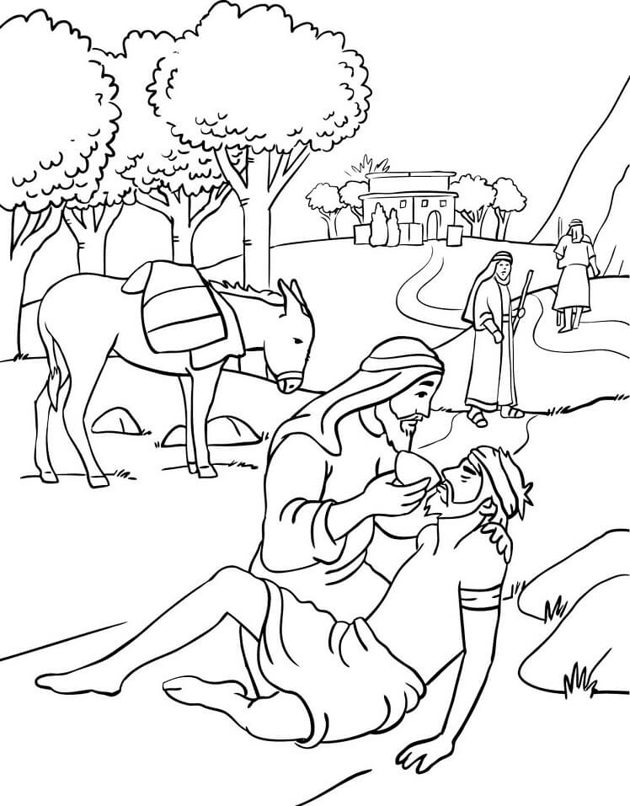

**Cambridge Causeway**

Summer 2022

Bible Study notes

**Following Jesus**

4. Love your neighbour

By Chrissy Cole